Brainstorm

& idea prioritization

Use this template in your own brainstorming sessions so your team can unleash their imagination and start shaping concepts even if you're not sitting in the same room.

**Before you collaborate**

A little bit of preparation goes a long way with this session. Here’s what you need to do to get going.

**10 minutes**

1. **Team gathering**

Define who should participate in the session and send an invite. Share relevant information or pre-work ahead.

1. **Set the goal**

Think about the problem you'll be focusing on solving in the brainstorming session.

1. **Learn how to use the facilitation tools**

Use the Facilitation Superpowers to run a happy and

CLASSIFICATION OF SAMPLES

USING VERISKIN DEVICE

**1**

## Define your problem statement

What problem are you trying to solve? Frame your problem as a How Might We statement. This will be the focus of your brainstorm.

**5 minutes**

**PROBLEM**

**HOW MIGHT WE DETECT THE ERYTHEMA?**

**PROBLEM**

**HOW TO DETECT THE SKIN CANCER IN EARLIER STAGES?**

**2**

## Brainstorm

Write down any ideas that come to mind that address your problem statement.

**10 minutes**

**DEVISHREE**

SKIN BOIPSY

**HARINI**

**TIP**

You can select a sticky note and hit the pencil [switch to sketch] icon to start drawing!

DETECT CANCER USING DEEP LEARNING

**3**

## Group ideas

Take turns sharing your ideas while clustering similar or related notes as you go. Once all sticky notes have been grouped, give each cluster a sentence-like label. If a cluster is bigger than six sticky notes, try and see if you and break it up into smaller sub-groups.

**20 minutes**

DETECTION

**TIP**

Add customizable tags to sticky notes to make it easier to find, browse, organize, and categorize important ideas as themes within your mural.

PERSONALIZE PATIENT CARE

# 

USING MACHINE LEARNING BASED METHODOLOGY

DETECT CANCER USING DEEP LEARNING

DEEP NEURAL NETWORKS

**4**

## Prioritize

Your team should all be on the same page about what's important moving forward. Place your ideas on this grid to determine which ideas are important and which are feasible.

**20 minutes**

# 

USING MACHINE LEARNING BASED METHODOLOGY

STAGING AND LAB RESULTS

## After you collaborate

You can export the mural as an image or pdf to share with members of your company who might find it helpful.

### Quick add-ons

1. **Share the mural**

**Share a view link** to the mural with stakeholders to keep them in the loop about the outcomes of the session.

1. **Export the mural**

Export a copy of the mural as a PNG or PDF to attach to emails, include in slides, or save in your drive.

**10 minutes** to prepare

**1 hour** to collaborate

**2-8 people** recommended

productive session.

[**Open article**](https://support.mural.co/en/articles/2113740-facilitation-superpowers)

### Key rules of brainstorming

To run an smooth and productive session

TECHNOLOGIES

USING MACHINE LEARNING BASED METHODOLOGY

SAMPLE SEGMENTATION

### Keep moving forward

**Strategy blueprint**

Define the components of a new idea or strategy.

[**Open the template**](https://app.mural.co/template/e95f612a-f72a-4772-bc48-545aaa04e0c9/984865a6-0a96-4472-a48d-47639307b3ca)

**Customer experience journey map**

Understand customer needs, motivations, and

Stay in topic. Defer judgment.

Encourage wild ideas. Listen to others.

**EZHILRAJ**

**BALAJI**

### Importance

SKIN BOIPSY

USING VERISKIN DEVICE

PRECISION IMAGING TECHNOLOGY

If each of these tasks could get

obstacles for an experience.

[**Open the template**](https://app.mural.co/template/b7114010-3a67-4d63-a51d-6f2cedc9633f/c1b465ab-57af-4624-8faf-ebb312edc0eb)

CLASSIFICATION OF SAMPLES

SAMPLE SEGMENTATION

DETECT CANCER USING DEEP LEARNING

**Strengths, weaknesses, opportunities & threats**

Go for volume. If possible, be visual.

PROCESSING

CLASSIFICATION OF SAMPLES

SAMPLE SEGMENTATION

STAGING AND LAB RESULTS

PERSONALIZE PATIENT CARE

DEEP NEURAL NETWORKS

PRECISION IMAGING TECHNOLOGY

CONVENIENT

done without any difficulty or cost, which would have the most positive impact?

Identify strengths, weaknesses, opportunities, and threats (SWOT) to develop a plan.

|  |  |
| --- | --- |
|  |  |
|  |  |

[**Open the template**](https://app.mural.co/template/6a062671-89ee-4b76-9409-2603d8b098be/ca270343-1d54-4952-9d8c-fbc303ffd0f2)

PRECISION IMAGING TECHNOLOGY

[**Share template feedback**](https://muralco.typeform.com/to/CiqaHVat?typeform-source=app.mural.co)

can use their int at where should go on facilitator can spot by using

**TIP**

Participants cursors to po sticky notes the grid. The confirm the

# FEATURES

nter holding the keyboard.

the laser poi

**H key** on the

EFFICIENT

PERSONALIZE PATIENT CARE

EFFICIENT

STAGING AND LAB RESULTS

DEEP NEURAL NETWORKS

[**Share template feedback**](https://muralco.typeform.com/to/CiqaHVat?typeform-source=app.mural.co)

CONVENIENT

### Feasibility

Regardless of their importance, which tasks are more feasible than others? (Cost, time, effort, complexity, etc.)

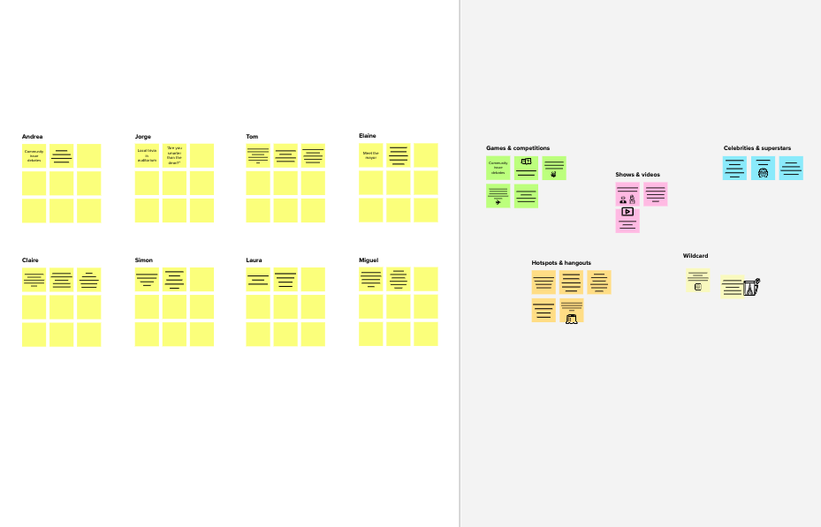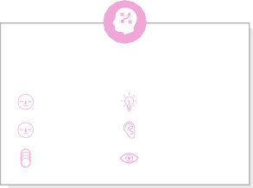

**Template**

#### Need some inspiration?

See a finished version of this template to kickstart your work.

[**Open example**](https://app.mural.co/template/e5a93b7b-49f2-48c9-afd7-a635d860eba6/93f1b98d-b2d2-4695-8e85-7e9c0d2fd9b9)